**Banking Application**

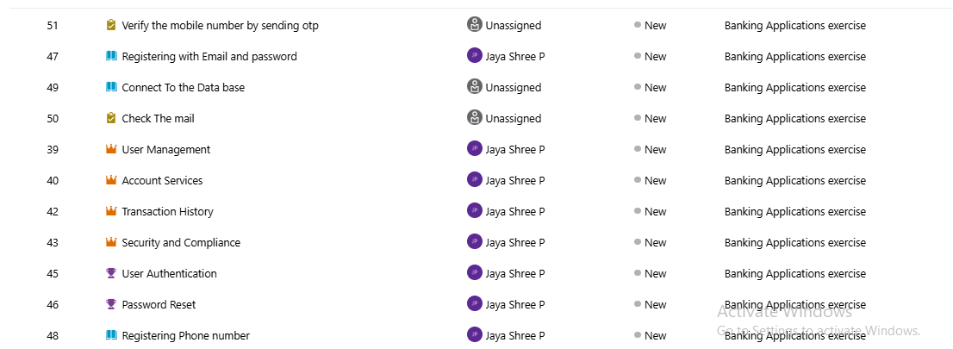

**Epic 1: Account Management**

**Feature: Customer Accounts**

* **User Story:** As a customer, I want to create and manage bank accounts so that I can access banking services.
  + **Tasks:**
    - Design account schema (Database)
    - Create API to open and close accounts
    - Store account details securely
    - Write unit tests for account APIs

**Feature: KYC & Compliance**

* **User Story:** As a bank officer, I want to verify customer identity so that the bank remains compliant.
  + **Tasks:**
    - Build KYC document upload module
    - Integrate with verification API
    - Store verification logs
    - Generate compliance reports

**Epic 2: Transactions**

**Feature: Fund Transfers**

* **User Story:** As a customer, I want to transfer money so that I can pay others easily.
  + **Tasks:**
    - Create transaction schema
    - Implement transfer API (NEFT/IMPS/RTGS)
    - Validate transaction limits
    - Write unit tests for transfers

**Feature: Transaction History**

* **User Story:** As a customer, I want to view my transaction history so that I can track my spending.
  + **Tasks:**
    - Build ETL pipeline for transactions
    - Store history in database
    - Develop API for statement retrieval
    - Create downloadable PDF statements

**Epic 3: Payments & Cards**

**Feature: Debit/Credit Card Management**

* **User Story:** As a customer, I want to manage my cards so that I can control usage.
  + **Tasks:**
    - Card issuance schema
    - API for activation/deactivation
    - PIN and limit management
    - Build fraud alerts

**Feature: Bill Payments**

* **User Story:** As a customer, I want to pay my utility bills so that I don’t miss due dates.
  + **Tasks:**
    - Integrate with biller APIs
    - Create recurring payments module
    - Store payment logs
    - Generate receipts

**Epic 4: Loans & Investments**

**Feature: Loan Management**

* **User Story:** As a customer, I want to apply for loans so that I can fund large expenses.
  + **Tasks:**
    - Loan application schema
    - Eligibility engine
    - Loan approval workflow
    - Repayment tracking

**Feature: Investments**

* **User Story:** As a customer, I want to invest in FDs and mutual funds so that I can grow my savings.
  + **Tasks:**
    - Investment schema
    - Integrate with market APIs
    - Build portfolio dashboard
    - Automate interest reports

**Epic 5: Security & Audit**

**Feature: Authentication & Authorization**

* **User Story:** As a customer, I want secure login so that my account is protected.
  + **Tasks:**
    - Implement MFA/OTP login
    - Role-based access control
    - Secure password storage
    - Unit test login

**Feature: Monitoring & Audit**

* **User Story:** As a bank admin, I want to track user activity so that I can detect fraud.
  + **Tasks:**
    - Build login/transaction logging pipeline
    - Store logs in secure storage
    - Monitor suspicious activities
    - Automate audit reports

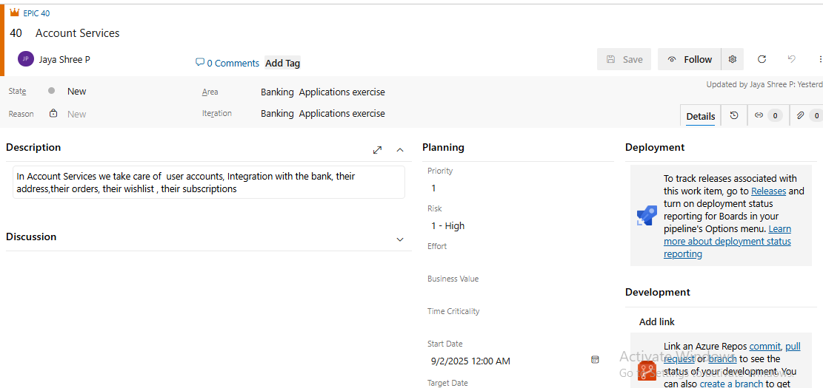

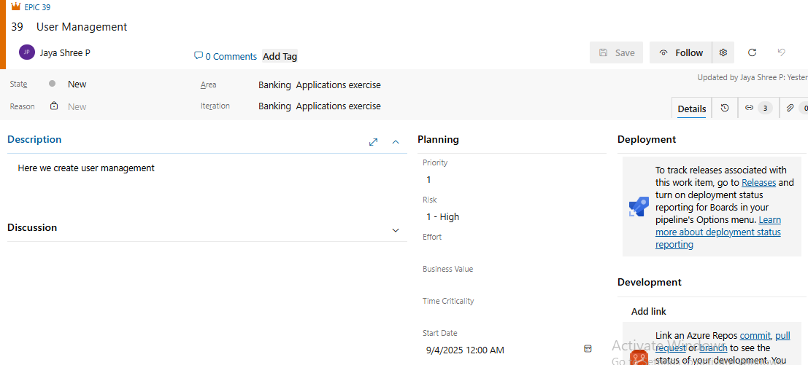

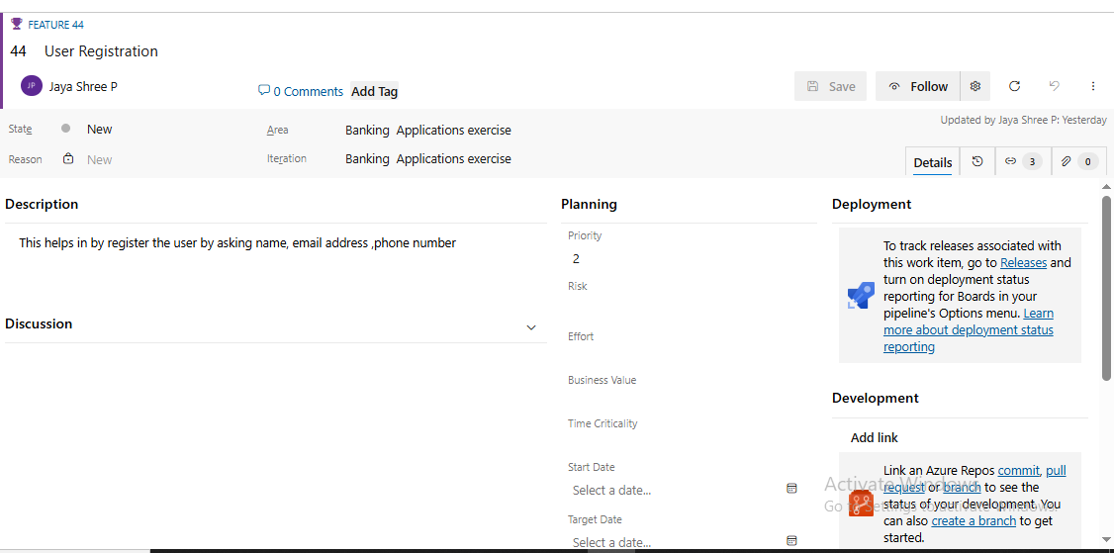

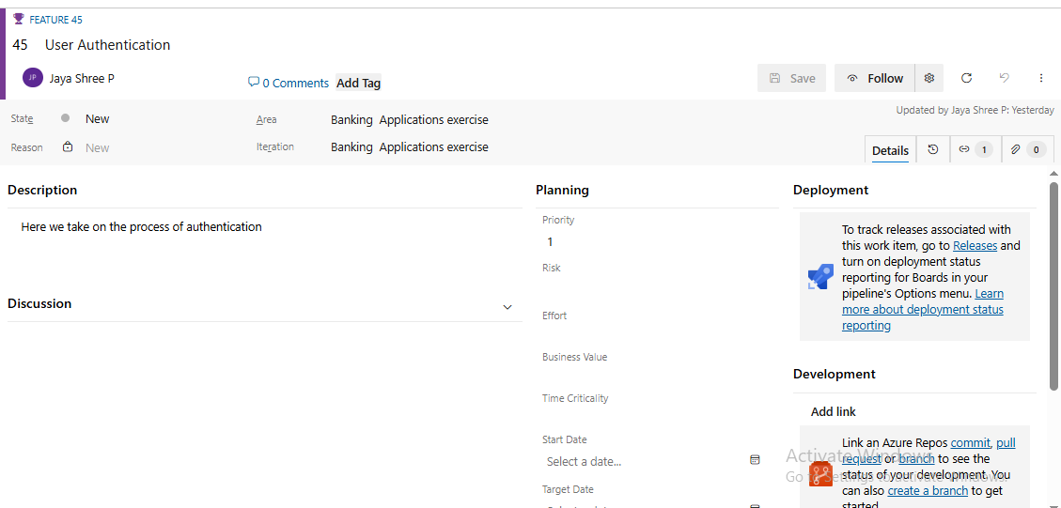

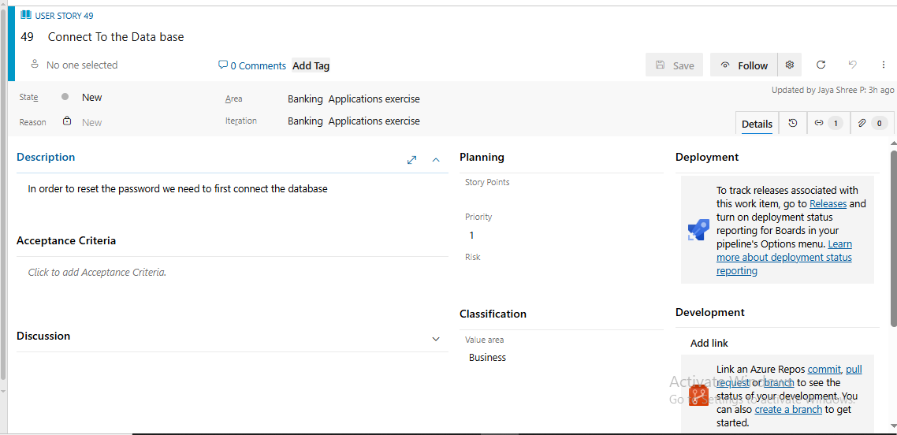

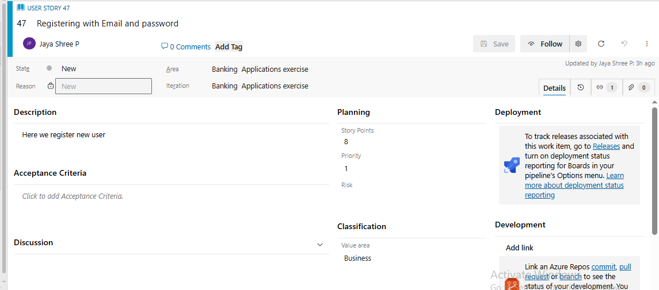

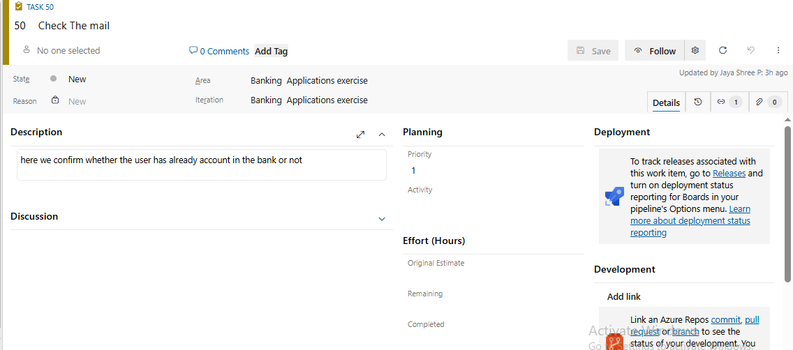

**CI/CD Pipelines:**

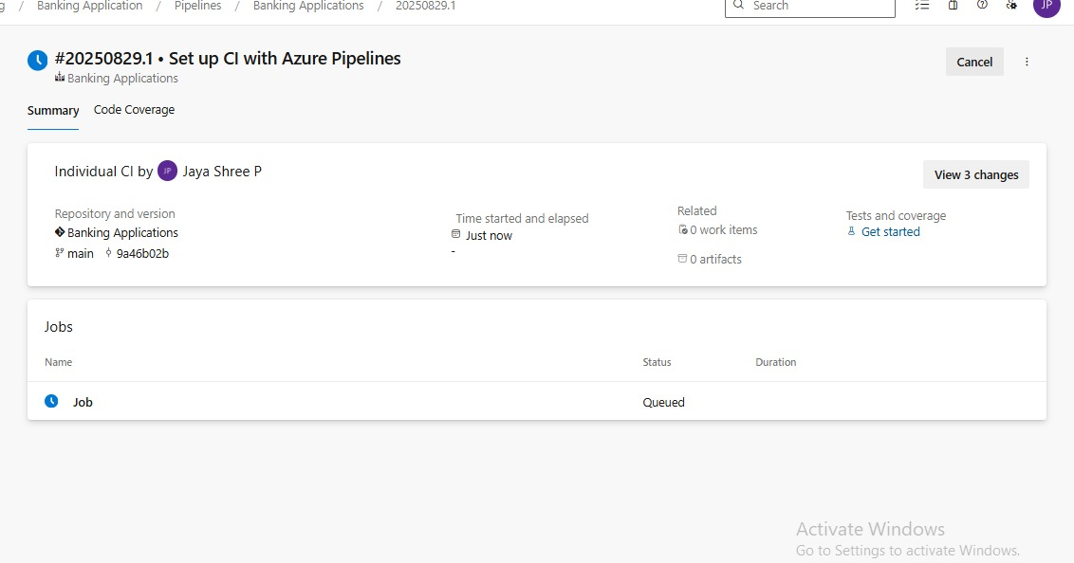

**Steps:**